SPARK: Simple Play Adaptations to Reference for Kids

Tic Tac Toe Built-In Switch Game
Description: | Image:
This adapted version of Tic Tac Toe is 11"L x 13½"W x 9½"H. It weighs 2 ¼ pounds and requires four AA batteries. Get “Tic Tac Toe” by activating a switch that lights up LED squares in a horizontal, vertical, or diagonal direction. The game board has two switch inputs so players can also use their own capability switches.  Purchasing Information  User’s Manual | 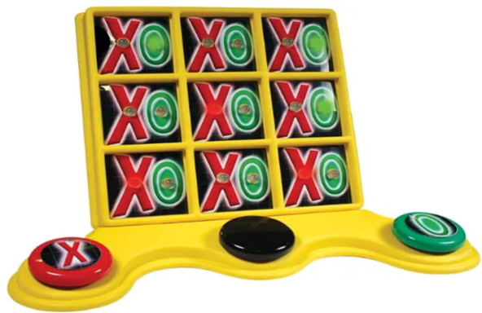

Who Might Benefit?
Those who…
• Benefit from simple cause and effect activities in which the child does something (activates a switch) and the game board lights up.
• Need to further develop reaching, targeting, and eye hand coordination.
• Need engaging visual and auditory materials to support attention to activity.
• Have fine motor challenges and are unable to engage in typical board game activities (rolling dice, picking up or moving game tokens, etc.)
• Struggle or are frustrated by manipulating small objects including marking tools.
• Have limited mobility or ability to assume varied play positions.
• Need more opportunities to interact with peers.
• Have visual impairments and benefit from engaging in high contrast-colored objects.

Why Use?
Provides an opportunity to…
• Develop experience using simple switches.
• Learn switch scanning which is useful for other activities including use of certain voice output devices, computer programs, and apps.
• Practice problem solving
• Develop cooperative play behaviors such as turn taking.
• Learn and play traditional paper-based marking game without holding a writing tool.
Instructions for Use: | Adaptation Ideas:
Environmental Considerations  - A flat surface (tabletop or floor) is needed with enough space for the adapted game board, and any additional switches.  - Use in any environment including community, home, and school. The product does have lights and sounds which may be disruptive in quiet environments.  Positioning  This game can be set up to allow access to users with multiple positional needs.  Position the child (sitting at a table, sitting on the floor, or lying on their tummy on the floor) along with “opponent” player so that they can view and reach the adapted game board and switches.  Basic Play/Use  - Players need to choose whether they are going to be the “X” player or the “O” player.  - Encourage each player in turn to press their switch.  - The black button is pushed to clear the last move.  - When one of the players gets three in a row, the lights on the adapted game board will flash and music will play.  Extended Play/Use  - Use this activity as a beginning counting game with one-to-one correspondence up to nine.  - Counting based on the shape (e.g. count all the O’s, count all the X’s).  - Cover portions of the squares with picture symbol cards so that the lights remain. Use as a beginning scanning activity.  - Take photos of the games in the Built-In Switch Adapted Game Kit and print the photos. Create a foam board choice board and encourage the child to select which game they would like to play. When the child selects, honor their choice by providing the selected game. Begin by providing 2 choices adding additional choices as the child tolerates.  Play/Use with Others  - Give each child in the class a turn using the adapted game board.  - Develop social scripts as necessary to teach turn taking.  - Model and teach turn taking with a “Your turn” card or by saying “your turn”.  - Teach sportsmanship using words like “good game”. | Optional Additional Materials/Supplies  - Velcro  - Dycem or shelf liner  - Carpet square  - Textured fabric  Build It Up  - Enlarge switch surface with textured fabric.  Stabilize It  - Velcro to carpet or use shelf liner to keep game and optional external switches from shifting out of reach.  - If the child is having difficulty controlling their reach to the switches, encourage the child to rest their forearm on the table while engaged in the activity which requires less control than using the entire arm.  Add Sensory Cues  - Apply various textures (e.g. Velcro, Dycem, shelf liner) to switch surfaces to add tactile interest.  Communication Support  - Use “Wait”, “My turn” “Your turn” “First/Then cards.  - Guide possible selections with pointing; use vocabulary such as “up” “down”, and “across”.  - Develop social scripts as necessary to teach turn taking.  Alternative Uses  - Switch user creates patterns with X’s and O’s, and play partner duplicates the pattern with pencil and paper, magnetic letters, etc.  - Model or compare with traditional paper and pencil Tic Tac Toe.  - Different types of switches could be trialed if the included switch is not usable by the child. The OCALI lending library has several kits with multiple types of switches that can be trialed.  DIY Alternatives  - Create a Tic Tac Toe grid on cardstock and laminate. Use Wikki Stix to form X’s and O’s or two colors of play doh to claim the spaces.

Additional Considerations:
- 4 AA batteries are required to be installed in the game board to work properly.
- Point with finger to help child track their available move to get three in a row.
- For children with auditory sensitivities, it should be noted there are sounds that accompany this game. Noise cancelling headphones could be used to help reduce the noise if needed and can be obtained from the OCALI lending library in the Sensory Regulation Kit.

Resources:
- Create a Choice Board - The OCALI Autism Center Grab and Go Resource Gallery of Interventions has a number of choice board templates and examples that could be used to create the choice boards indicated above in the Extended Play/Use section. Additionally, there are several examples of different ways choice boards can be effectively displayed.

Ohio Early Learning Standards:
- SE: Relationship Skills. Develops socially competent behaviors with peers (4.b.)
- SC: Science Inquiry and Application: Develops ability to reason about cause and effect. (1.b.).

Words to Encourage Play/Use
Look  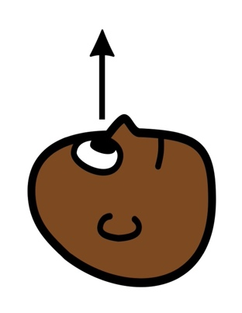 | Find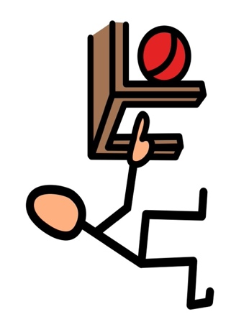 | Push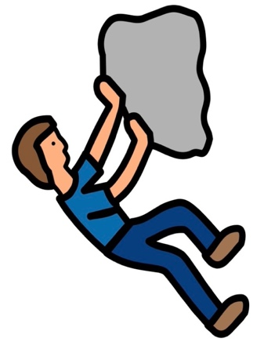
Stop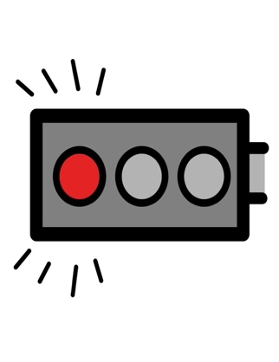 | Go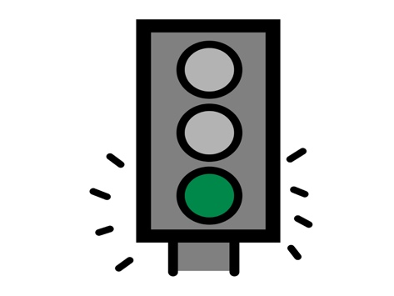 | Done  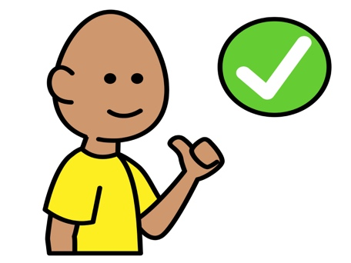
Your turn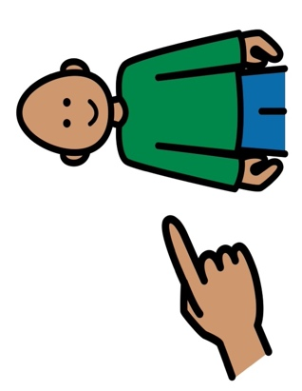 | My turn  | Wait  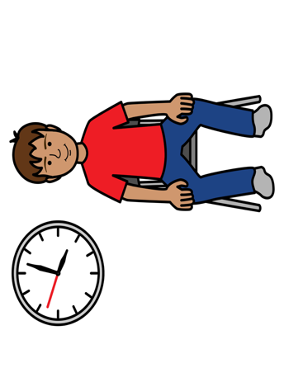
*”Adaptations” adapted from: Haugen’s Modes for Adapting Toys based on materials from the "Let's Play" Project at the University of Buffalo
PCS is a trademark of Tobii Dynavox, LLC. All rights reserved. Used with permission.

